**AMERICAN INTERNATIONAL UNIVERSITY–BANGLADESH (AIUB)**

**FACULTY OF ENGINEERING**

**DEPARTMENT OF COMPUTER ENGINEERING**

**DATA COMMUNICATION LABORATORY**

**Fall 2023-2024  
Section: I**

**Group: 4**

**EXPERIMENT NO: 7 (Part 1)**

***Study of Amplitude Modulator and Demodulator using Simulink***

|  |  |
| --- | --- |
| **Name** | **ID** |
| 1. MD. SHAHRIAR PARVEZ SHAMIM | 21-44998-2 |
| 2. MD. AL FAIAZ RAHMAN FAHIM | 21-45080-2 |
| 3. MD. OMAR FARUK SAKIB | 21-45077-2 |
| 4. MD. ABU HOJIFA | 21-45081-2 |
| 5. ASHFAT AHMAD MEDUL | 21-44854-2 |

**Submitted By:**

**Date of Submission**: **December 26, 2023**

**Abstract:**

This experiment is designed to enhance understanding and practical application of Amplitude Modulation (AM) and demodulation using Simulink. Participants will utilize Simulink to implement AM modulation, gaining hands-on experience in signal generation. The focus then shifts to understanding AM demodulation techniques, potentially involving the use of filters. Overall, the experiment provides a comprehensive learning opportunity for participants to explore and apply AM modulation and demodulation concepts in a Simulink environment.

**Introduction:**

Amplitude modulation (AM) is a one of the conventional technique used to transmit message signals using a carrier wave. The amplitude or strength of the high frequency carrier wave is modified in accordance with amplitude of the message signal. [1] [2]

* Carrier signal (Sc) = Acsin(2πfct)
* Message signal (Sm) = Amsin(2πfmt)   # fm must be smaller than fc

When carrier amplitude is altered with respect to message signal,

* Modulated Signal = (Ac+ Amsin(2 πfmt))*sin(2 πfct)

In terms of modulation index (m=Am/Ac) the equation becomes

* **Modulated signal= (1+ msin(2 πfmt))*Acsin(2 πfct)**

Where,

* Ac= Carrier signal amplitude
* Am= Message signal amplitude
* fc= Carrier frequency
* fm =Message frequency

**Generating AM in Simulink**

For generating AM we just have to implement the equation of AM in block level.

**Blocks Required**

Analyzing the equation we need,

1. Carrier Signal Source
2. Message Signal Source
3. Blocks for viewing the signals – Scope
4. Product Block
5. Summer Block
6. Constant Block

We can find these blocks in the following locations of Simulink Library…

**Carrier, Message, Constant blocks**

* Simulink –> Sources –> Sine wave
* Simulink –> Sources –> Constant

**View Block**

* Simulink –> Sink –> Scope

**Product and Summer Block**

* Simulink –> Math Operations–> Product
* Simulink –> Math Operations–> Summer

**Block Diagram**

**Figure 1:** AM Modulation **Figure 2:** AM Modulation & Demodulation

Block parameters can be changed by selecting the block and parameter:

* Carrier Signal frequency = 2*pi*3 and sampling time=1/5000
* Message Signal frequency = 2*pi and sampling time=1/5000
* Amplitudes of both signals are 1

**Results:**

[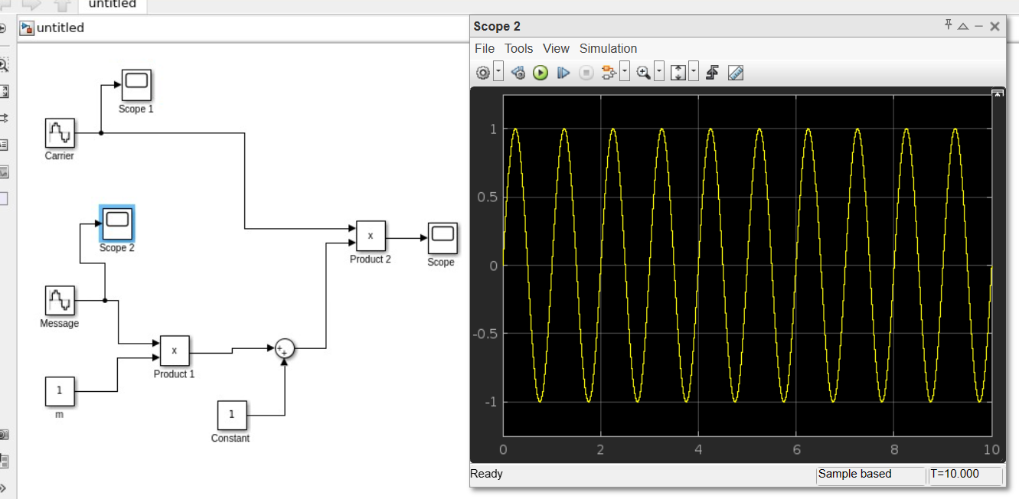](https://electrosome.com/wp-content/uploads/2013/11/AM-Generation-using-Simulink-Message-Signal.jpg)

***Figure 3:*** *AM Generation using Simulink – Message Signal*

[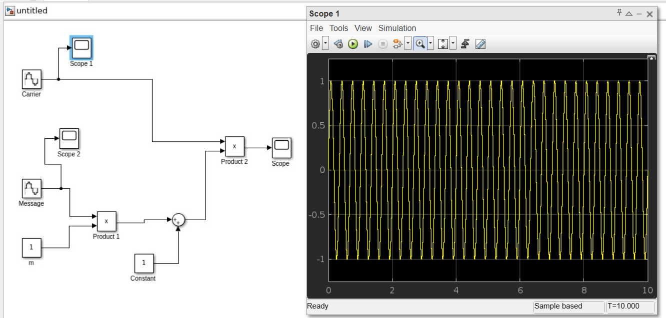](https://electrosome.com/wp-content/uploads/2013/11/AM-Generation-using-Simulink-Carrier.jpg)

***Figure 4:*** *AM Generation using Simulink – Carrier*

[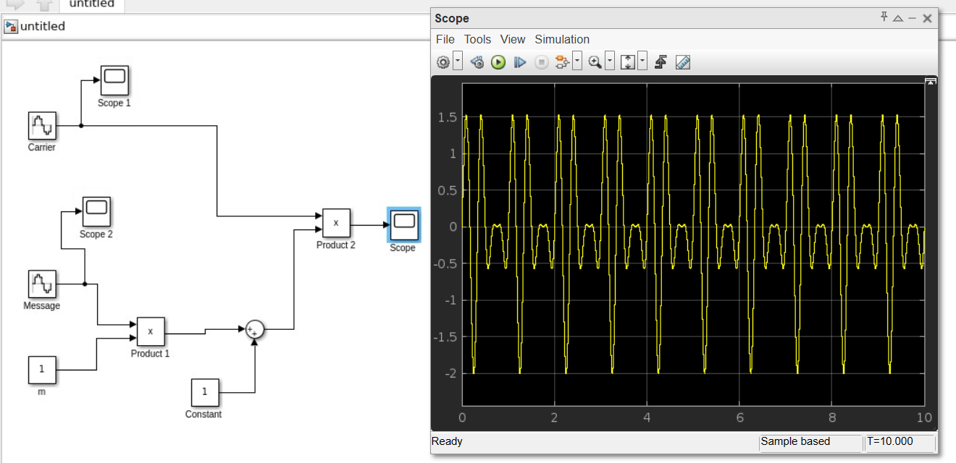](https://electrosome.com/wp-content/uploads/2013/11/AM-Generation-using-Simulink-Modulated-Signal.jpg)

***Figure 5:*** *AM Generation using Simulink – Modulated Signal*

**Performance Task:**

**Question:**

**Implement the following demodulation in Simulink to retrieve the original signal:**

You have a signal ‘m(t) = (2*sin(2*pi*4*t)+3*cos(2*pi*6*t))’. Apply amplitude modulation (AM) on the given signal with carrier signal ‘c(t) = cos(2*pi*50*t)’, and then do demodulation to recover the original message signal m(t).

[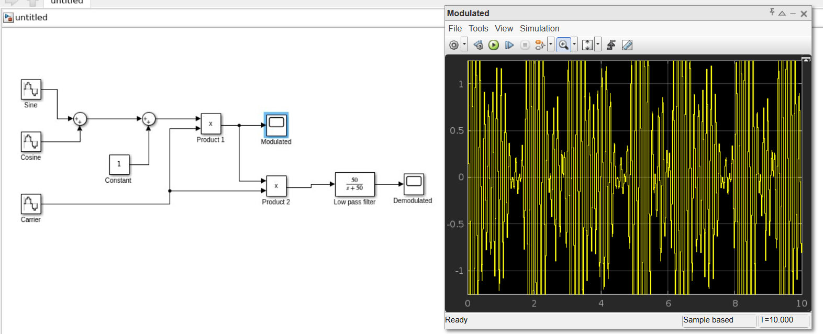](https://electrosome.com/wp-content/uploads/2013/11/AM-Generation-using-Simulink-Message-Signal.jpg)**Answer:**

***Figure 6:*** *AM Generation*

[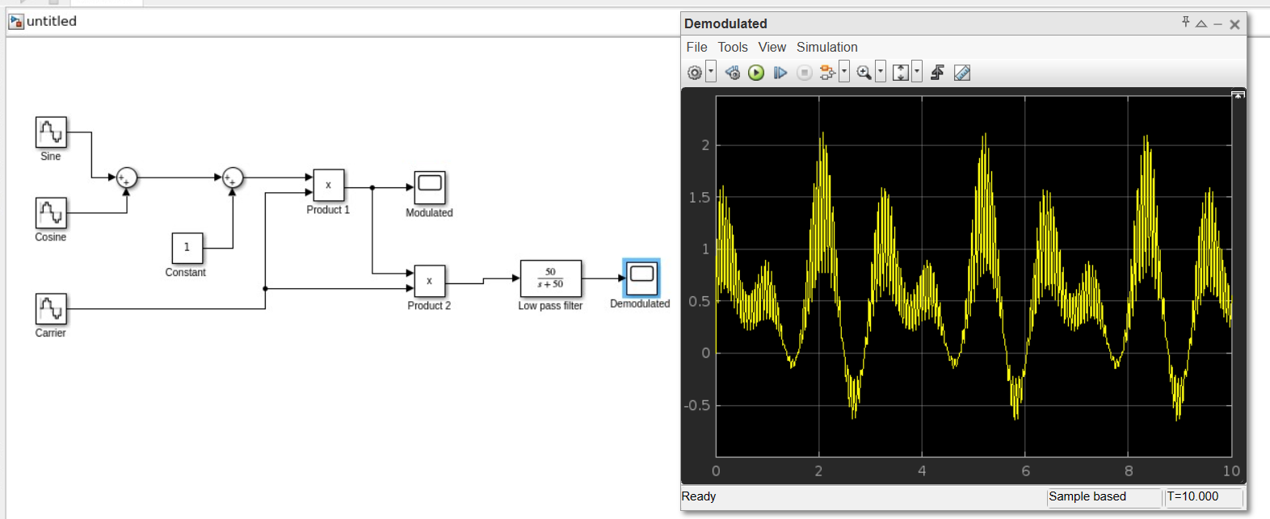](https://electrosome.com/wp-content/uploads/2013/11/AM-Generation-using-Simulink-Carrier.jpg)

***Figure 7:*** *AM Demodulation*

[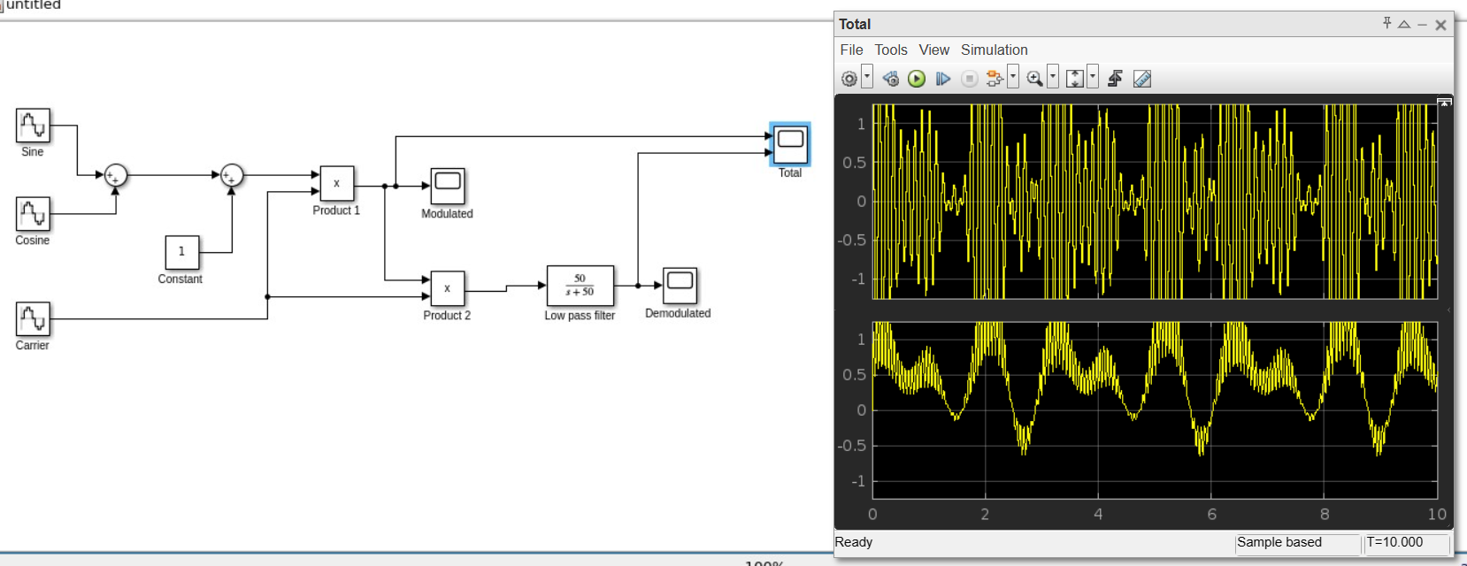](https://electrosome.com/wp-content/uploads/2013/11/AM-Generation-using-Simulink-Modulated-Signal.jpg)

***Figure 8:*** *Modulation and Demodulation in single Scope*

**Discussion & Conclusion:**

The experiment involved implementing an amplitude modulator and demodulator in Simulink using MATLAB. Sine and cosine values were chosen as per the task requirements, and necessary components like scopes and math functions were included for the desired output. This hands-on application within the Simulink environment provided practical insights into amplitude modulation techniques. The successful execution of modulation and demodulation tasks demonstrated the effective application of theoretical concepts in a MATLAB context.

**References:**

**[1]** W. Stallings, Data and computer communications. 2000., Accessed: Nov.24, 2023. [Online].

Available:<https://www.portcity.edu.bd/files/636444710465881602_Dataandcomputercommunications.pdf> [Online Copy]

**[2]** B. A. Forouzan, C. A. Coombs, and S. C. Fegan, Introduction to data communications and networking. McGraw-Hill Science, Engineering & Mathematics, 1998., Accessed: Nov.24, 2023. [Online]. Available: <https://archive.mu.ac.in/myweb_test/syllFybscit/dcn.pdf> [Online Copy]

**AMERICAN INTERNATIONAL UNIVERSITY–BANGLADESH (AIUB)**

**FACULTY OF ENGINEERING**

**DEPARTMENT OF COMPUTER ENGINEERING**

**DATA COMMUNICATION LABORATORY**

**Fall 2023-2024  
Section: I**

**Group: 4**

**EXPERIMENT NO: 7 (Part 2)**

***Study of Frequency Modulation and Demodulation using Simulink (MATLAB)***

|  |  |
| --- | --- |
| **Name** | **ID** |
| 1. MD. SHAHRIAR PARVEZ SHAMIM | 21-44998-2 |
| 2. MD. AL FAIAZ RAHMAN FAHIM | 21-45080-2 |
| 3. MD. OMAR FARUK SAKIB | 21-45077-2 |
| 4. MD. ABU HOJIFA | 21-45081-2 |
| 5. ASHFAT AHMAD MEDUL | 21-44854-2 |

**Submitted By:**

**Date of Submission**: **December 26, 2023**

**Abstract:**

This experiment aims to enhance comprehension of communication engineering problem-solving through the utilization of Simulink. The focus lies on two primary objectives: firstly, gaining insight into the application of Simulink for addressing communication engineering issues, and secondly, fostering a deep understanding of Frequency Modulation and Demodulation processes through Simulink simulations. The study involves practical exploration and application of Simulink tools to navigate and solve challenges within the realm of communication engineering, with a specific emphasis on the intricacies of Frequency Modulation and Demodulation techniques.

**Theoretical Background:**

If m(t) is message signal, the frequency modulated signal is expressed as in time domain:

Frequency Demodulation

Phase Locked Loop (PLL) Demodulation: The PLL demodulates the FM signal using feedback force a Voltage-Controlled-Oscillator (VCO) to remain in phase with the carrier of the incoming signal. The message is recovered as the control input of the VCO [2]. In the simulation experiment we used the VCO to demodulate the information signal. [1] [3]

**Building Simulink Model of Frequency Modulation and Demodulation:**

The frequency modulator and demodulator structures are as explained below. In the first model, you are provided a FM structure that is very similar to the theoretical background of this experiment. In the second model, you will observe the PLL frequency demodulator blocks provided by Simulink. [3]

Frequency Modulation:

The Simulink model for FM modulator is:

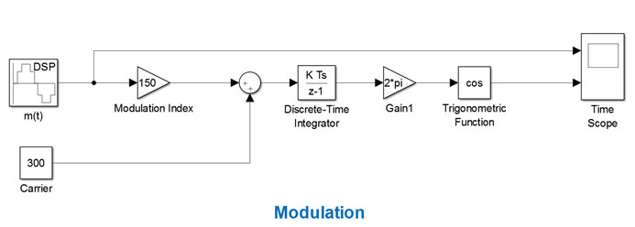Figure 1: Block Diagrams for the FM Modulator [3]

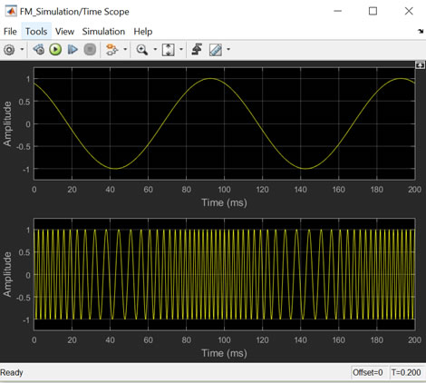

Figure 2: Time Scope [3]

Frequency Modulator and Demodulator:

The Simulink model of the complete FM modulator and demodulator is shown next:

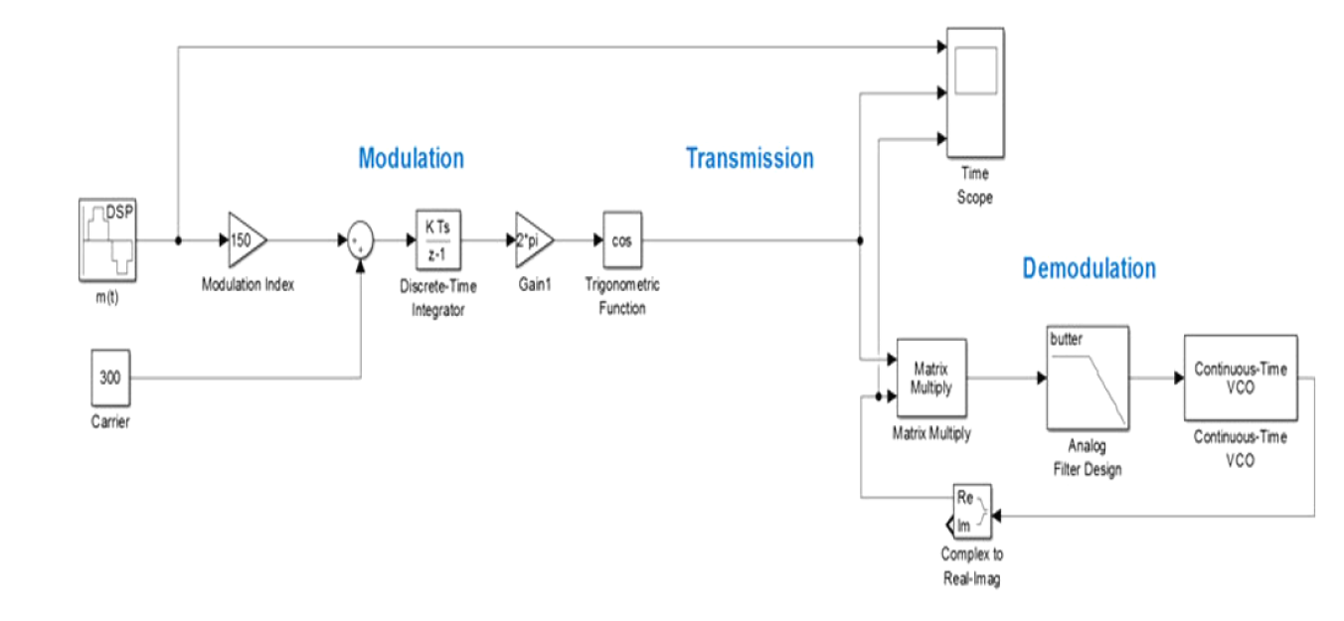Figure 3: FM Modulator and Demodulator [3]

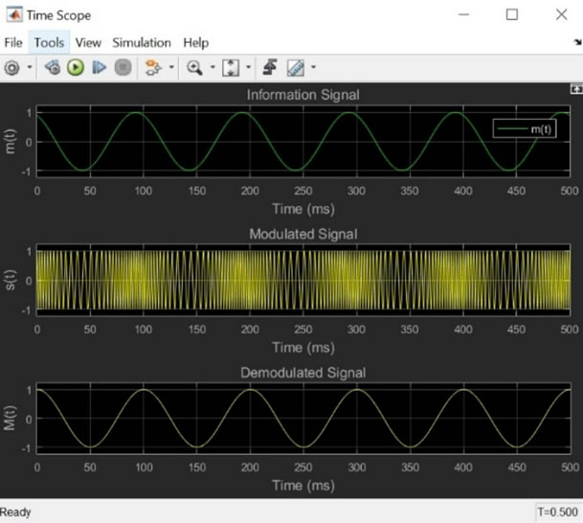

Figure 4: Time Scope for Model-1 [3]

**Performance Task:**

**Question:**

Message signal, m(t) = a*sin(2πfmt + π/3), a = 2, fm = 10. Use FM modulation and demodulation on the given signal and use two scopes to show your output.

First scope should show message signal and modulated signal. Second scope should show message signal and demodulated signal.

Lab Report must contain (a) A block diagram of FM modulator, (b) A block diagram of FM demodulator, (c) A block diagram of FM modulator and demodulator in a single window, (d) Two scope figures.

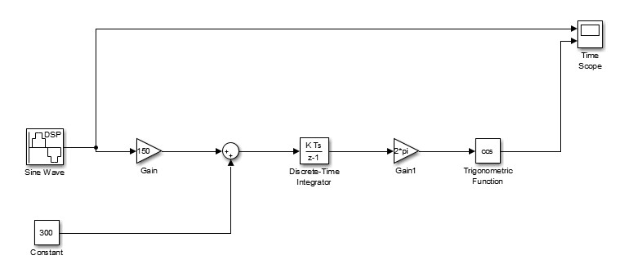**Answer**:  
  
**a)** Figure 5: FM Modulation

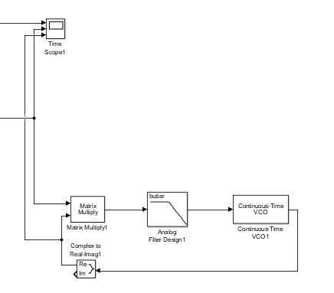**b)**

Figure 6: FM Demodulation

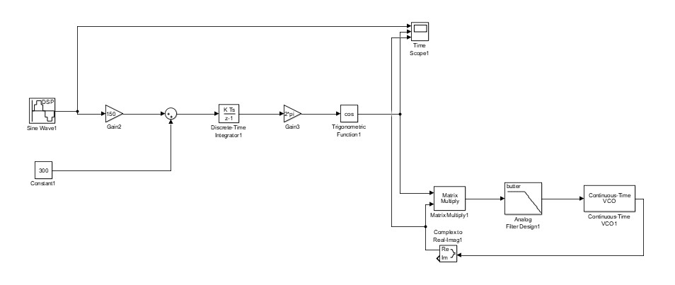**c)** Figure 7: FM Modulation and Demodulation

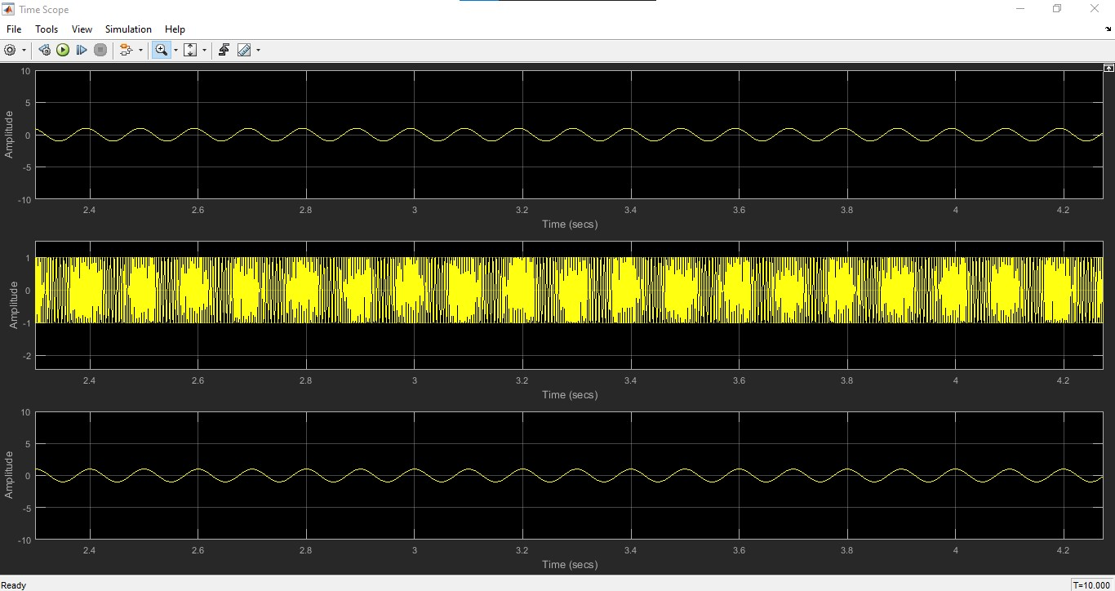**d)**

Figure 8: Two scope image of Modulation and Demodulation

**Discussion & Conclusion:**

In this study, the utilization of MATLAB-based Simulink for Frequency Modulation (FM) and Demodulation processes was explored. The simulation involved the generation of a sine wave as a message signal, followed by modulation and subsequent demodulation stages. Key components such as gain, integrator, trigonometric functions, sine wave generators, analog filter design, and continuous-time voltage-controlled oscillators (VCOs) were employed in the simulation. The inclusion of a time scope function facilitated the visualization of the output throughout the process. By systematically inputting values into the designated fields, the expected results were obtained. This experiment underscores the efficacy of Simulink in modeling and analyzing Frequency Modulation and Demodulation in a controlled MATLAB environment, offering valuable insights for communication engineering applications.

**References:**

**[1]** W. Stallings, Data and computer communications. 2000., Accessed: Nov.24, 2023. [Online].

Available:<https://www.portcity.edu.bd/files/636444710465881602_Dataandcomputercommunications.pdf> [Online Copy]

**[2]** B. A. Forouzan, C. A. Coombs, and S. C. Fegan, Introduction to data communications and networking. McGraw-Hill Science, Engineering & Mathematics, 1998., Accessed: Nov.24, 2023. [Online]. Available: <https://archive.mu.ac.in/myweb_test/syllFybscit/dcn.pdf> [Online Copy]

**[3]** Lab Manual Accessed: Nov.24, 2023.